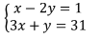
Example 1: Solve the system of linear equations by elimination

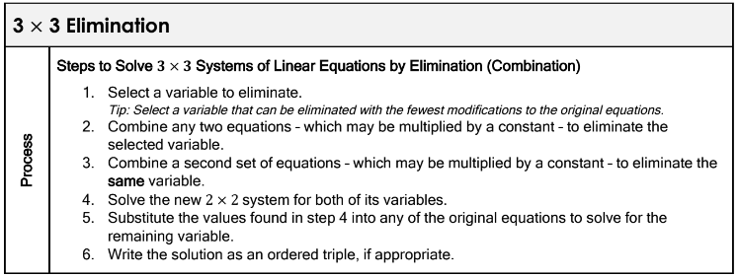
Example 2: Solve the system of linear equations by elimination
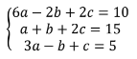

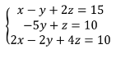
Example 3: Solve the system of linear equations by elimination

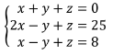
Example 4: Solve the system of linear equations by elimination

